**1.Linear Search**

#include <stdio.h>

int main()

{

int a[100],n,i,target;

printf(“Enter number of elements:”);

scanf(“%d”,&n);

printf(“Enter %d elements:”,n);

for(i=0;i<n;i++){

scanf(“%d”,&a[i]);

}

printf(“enter Target element:”);

scanf(“%d”,&target);

for(i=0;i<n;i++){

if(target==a[i]){

printf(“%d is found at index %d”, target,i);

break;

}

}

if(i==n)

printf(“%d not found “,target);

return 0;

}

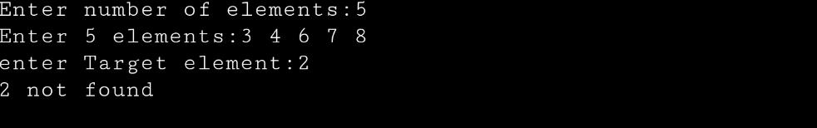

**2.Binary Search**

#include <stdio.h>

int main()

{

int a[100],n,i,target,low, high,mid;

printf(“Enter number of elements:”);

scanf(“%d”,&n);

printf(“Enter %d elements:”,n);

for(i=0;i<n;i++)

scanf(“%d”,&a[i]);

printf(“enter Target element:”);

scanf(“%d”,&target);

low=0;

high=n-1;

mid=(low+high)/2;

while(low<high){

if(a[mid]<target)

low=mid+1;

else if(a[mid]==target){

printf(“%d found “,target);

break;}

else(a[mid]>target);

high=high-1;

mid=(low+high)/2;

}

if(low>high)

printf(“unsuccessful search”);

return 0;

}

